Top of Form

Argument matching syntax in Python functions

**stepanyanm17@gmail.com** [Switch account](https://accounts.google.com/AccountChooser?continue=https://docs.google.com/forms/d/e/1FAIpQLSft4M2qrsgoLbfnwbgjhSRZ55_CRBhEKz2xCfTccTBt9oCDNg/viewform?usp%3Dsend_form&service=wise)

Not shared

* Indicates required question

Անուն Ազգանուն*



Your answer

What is the interpretation of the following function call? func(*iterable)

10 points

Pass all objects iterable as individual positional arguments

Pass all key/value pairs in dict as individual keyword arguments

Keyword argument: matched by name

Normal argument: matched by position

What will be the output of the following code?

10 points

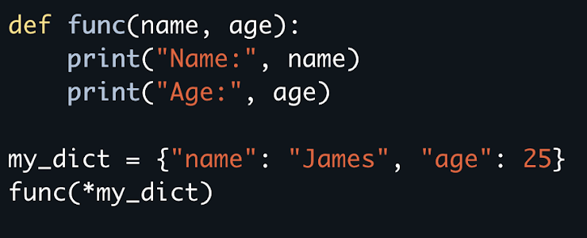

Name: James Age: 25

James : 25

Syntax Error

Name: name Age: age

When you use a built-in function in your code, what steps occur?

10 points

The function evaluates, the function produces a side effect, and the function closes.

The function is called, the function executes, and the function returns.

The function opens, the function evaluates, and the function closes.

The function is imported, the function executes, and the function returns.

Which of the following are rules for naming a function?

10 points

A function name must include parentheses.

A function name can contain letters, numbers, or underscores.

A function name cannot begin with a number.

A function name cannot begin with an underscore.

What will be the output of the following code?

10 points

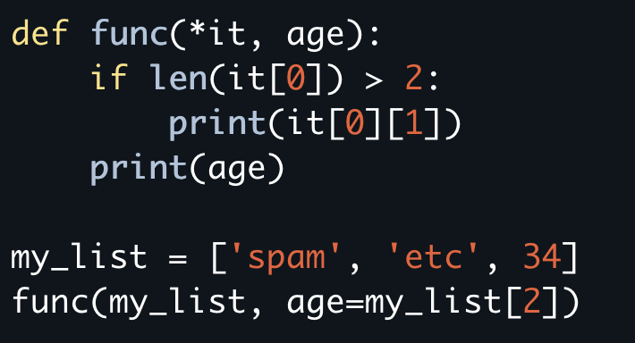

34

34 34

etc 34

Syntax error

spam 34

What will be the output of the following code?

10 points

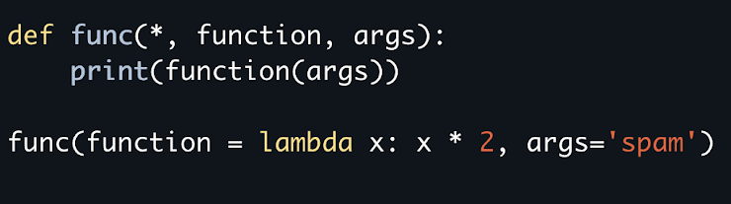

spamspam

<function <lambda> at 0x1098e1e10>

TypeError: func() takes 0 positional arguments but 1 positional argument

spam

What will be the output of the following code?

10 points

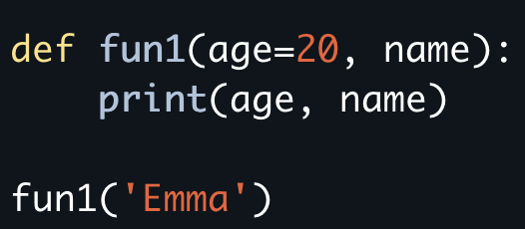

20 Emma

SyntaxError: non-default argument follows default argument

Emma

What will be the output of the following code?

10 points

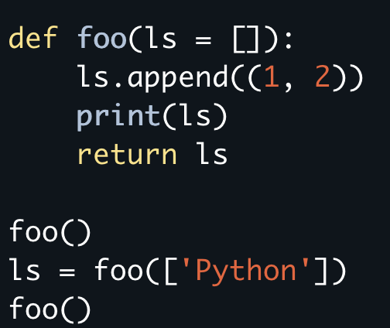

[ (1, 2) ] [ 'Python', (1, 2) ] [ (1, 2), (1, 2) ]

[ (1, 2) ] [ 'Python', (1, 2) ] [ 'Python', (1, 2), (1, 2) ]

[ (1, 2) ] [ 'Python', (1, 2) ] [ (1, 2) ]

AttributeError: 'str' object has no attribute 'append'

What will be the output of the following code?

10 points

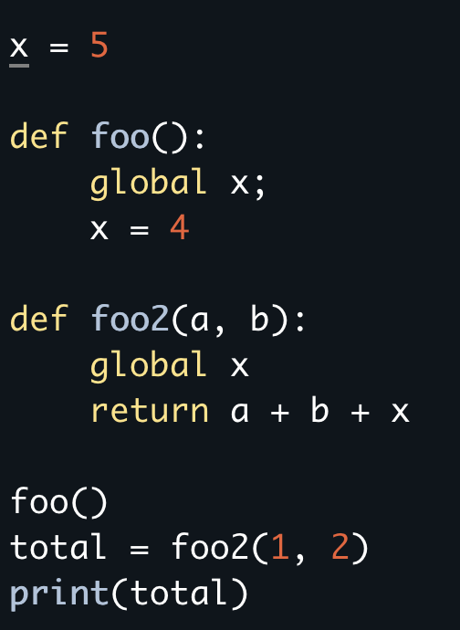

NameError: name 'x' is not defined

7

15

8

What will be the output of the following code?

10 points

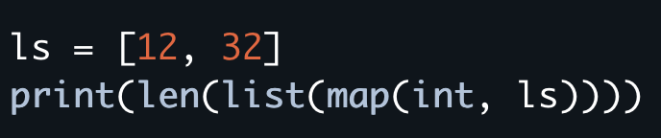

2

12

32

What is map?

Submit

Clear form

Never submit passwords through Google Forms.

Bottom of Form

This content is neither created nor endorsed by Google. [Report Abuse](https://docs.google.com/forms/u/0/d/e/1FAIpQLSft4M2qrsgoLbfnwbgjhSRZ55_CRBhEKz2xCfTccTBt9oCDNg/reportabuse?source=https://docs.google.com/forms/d/e/1FAIpQLSft4M2qrsgoLbfnwbgjhSRZ55_CRBhEKz2xCfTccTBt9oCDNg/viewform?usp%3Dsend_form) - [Terms of Service](https://policies.google.com/terms) - [Privacy Policy](https://policies.google.com/privacy)

[Forms](https://www.google.com/forms/about/?utm_source=product&utm_medium=forms_logo&utm_campaign=forms)